Generative AI Spear Phishing

Mason Dornier, Daniel Guo, Adithya Anand, Aaron Zuvich

Division of Computer Science and Engineering
College of Engineering
Louisiana State University and A & M College

Abstract
The rise of generative artificial intelligence (AI) has advanced the cybersecurity industry, but it has also enabled cybercriminals to create more sophisticated phishing attacks. AI allows attackers to create highly convincing and personalized messages at scale, making phishing detection increasingly difficult. Traditional detection methods, which rely on generic templates and linguistic errors, are less effective against AI-generated emails due to their human-like structure and coherence. This paper presents a machine learning-based system designed to detect legitimate human, human phishing, and AI-based phishing messages. The model is trained on a dataset comprised of 1,000 AI-generated emails from GPT, Claude, Gemini, and open-source LLMs, alongside human emails from the Enron dataset. Our detection uses three primary approaches: stylometric features, statistical perplexity analysis, and neural features, combined with vector embeddings to convert text into machine-readable input. A Roberta classifier was used to categorize messages into boxes labeled as AI-generated or human, respectively. Evaluation results show an overall accuracy of 93.7%, with 97.2% for legitimate emails, 96.3% for human phishing, and 87.5% for AI phishing. These findings show that human and traditional phishing can be reliably detected, while AI-generated phishing is harder to identify due to the polished grammar and fewer linguistic cues. Our solution provides an effective approach for identifying AI-generated phishing emails and creates a foundation for the cybersecurity community in the defense against AI spear phishing attacks.
Keywords—Spear Phishing, AI, Solutions for AI spear phishing

Introduction
Phishing is one of the most common forms of cyberattacks, but the rise of generative AI has made these attacks far more sophisticated by allowing cybercriminals to tailor phishing messages to the person they are sending them to. Before generative AI, phishing messages were easy to detect because they used generic wording, clear templates, and recognizable formats. With the use of AI, attackers can scrape publicly available data off the internet relevant to their target and generate messages that appear personal and professional. AI phishing has already caused catastrophic damage to multiple companies. One example of these types of attacks is a case from 2019 where criminals used AI-generated voice synthesis to mimic a German CEO’s speech patterns, convincing an employee at a UK energy firm to transfer €220,000 to a fraudulent account. According to reports by The Wall Street Journal, the employee believed he was speaking directly to his superior [2]. This demonstrates how credibility is gained by using AI in spear phishing attacks. Incidents like this show how important it is to have measures in place to protect against AI spear phishing. There are tools that block known phishing emails, but current security systems are not designed to protect against this new style of phishing. Traditional filters, such as those for spelling errors or malicious links, are ineffective because AI-generated messages do not contain anything that would trigger these blocks. This gap in detection creates a major cybersecurity problem. To address this problem, our research proposes a machine learning-based detection system that analyzes AI spear phishing along with many other factors that indicate AI writing. This paper provides a design and implementation with the goal of reducing the success rate of AI phishing attacks. By training our model on AI and human-written emails, we aim to improve detection and provide users with warnings rather than just blocking messages, because it is also possible that an AI written email is legitimate, and this approach allows users to make informed decisions while maintaining security.

Background and Related Work
The core idea of this project is the minimization of successful AI generated phishing attacks. The idea is that next generation AI uses publicly available information of individuals or companies to send socially engineered malicious emails. Typically, these emails ask for company or personal credentials that once put in, are stolen. AI generated attacks are more problematic however, due to it’s accuracy and availability. Anyone can get AI to create a believable email and website to get a user to put their information in to steal. An example of an AI generated attack was in 2019 when a UK energy firm CEO wired 200,000+ dollars to a malicious actor. He used voice modifying AI to mimic the CEO’s boss at the firm’s parent company to convince him. This is an example of a next generation attack that we should be aware of and aim to prevent. Our solution uses machine learning AI to analyze patterns in AI email generation to poke out if an email was made by AI. In addition, it will scan links in AI generated emails to test if they are malicious or authentic. Other programs like this have been made, but not with this specific combination. An example company is TitanHQ. Their company uses a quick setup to efficiently filter out phishing emails using antivirus and AI language analysis. They have features such as phishing firewalls and malicious email clear out that are used to keep a safe email account. However, our idea is a bit of a more hands-off approach that allows the user to make their own decision if they want to engage with the email. Instead of completely blocking the emails suspected of being malicious, we intend to incorporate flags. Each flag will indicate one of two things. A flag means either the email has a certain percentage of being AI generated or an email link’s percentage of being malicious. These flags will allow users to make their own decisions if they want to follow through with the link or email with better context of the email. This way companies and users can be well informed about the emails they are receiving and make their own decisions on what to do with them.

Methodology
This detector is oriented around machine learning of AI linguistic patterns to distinguish between human and AI generated emails.
- Building A Data Set
  - To build a data set for our model, we have positive and negative partitions. For our positive data set, 1,000 AI emails will be generated from GPT versions, Claude, Gemini, and open source LLMs like LLaMA and Mistral. We will divide the prompts given by quarters. Each quarter will be prompted separately for personal emails, business emails, support emails, and phishing emails. We will also give each quarter 4 other quarters of prompts asking for increasing temperature and variation in tone. For example, a prompt would read “Generate 250 formal business emails with a temperature range from .2 to .5, with an urgent tone.” For our negative data set we will use the public email database Enron, which contains 500,000 plus human made emails ranging from personal to business. Before we enter these human-made emails into the database, we will have to filter out personal information to keep data privacy and purity.
- Engineering Approaches
  - We will use 3 primary approaches to observe and make sense of the raw text. These 3 approaches are Stylometric Features, Statistical Perplexity Analysis, and Neural Features. Stylometric features include vocabulary diversity and distribution of rare words. Syntactic features such as average sentence length, grammatical frequencies, and sentence structure allow another level of noticing how AI is formulating sentences. Finally, using Statistical Perplexity Analysis we can observe how predictable a text is to a language model. With these features, we will be able to put AI generated output into defined boxes. For example, we can first compare the stylometric features to different temperatures to discover the most likely language model that made the text. Then syntactic features that AI uses include low sentence length variation, repetitive noun, verb, and adverb structure, and consistently correct sentence structure all point to AI. Humans very often have variation in these aspects, which makes it easier to identify AI when there is very little variation. Using the previously established information, we can check the perplexity of the raw text by comparing it to the assumed LLM model. Using our positive data set, we should be able to compare what words are expected next from the LLM model with the actual words from the raw text. If they have a high correlation, it is indicative of AI usage.
  - However, ML cannot understand the pure raw text. What it needs is vector embedding. What the above process will do, along with vector extracting, is create an ML readable input. It will convert the raw text into a numerical form that can be compared to each other. For example, words with similar meanings will be closer in numerical values like “fly” and “soar”. However, words that are spelled the same as saw(look) and saw(cutting) will be farther in numerical value. In practicality, the model will compare the vectors to find ranges and the larger the range the more likely a human wrote it since they are more irregular in their structure. AI is smooth and consistent with its structure, which will provide a narrower range.
- Train an ML Classifier
  - We will use the Roberta classifier for our purposes as it will provide the most accurate results for our purposes. In this step our goal is to accurately put emails into boxes of AI or Human. We will train the classifier using our given constraints above to identify what points to AI versus human.
- Ensemble the Signals
  - Using each of the engineering approaches, we will allow a weighted vote from each. They will decide whether they think the text is AI or human and cast their vote. The percentage of certainty will be the approaches that designated the text as AI. For example, if a text given has all approaches to vote for AI besides one, the confidence percentage of it being AI is very high.
- Advanced Features
  - To distinguish ourselves from existing models in this area, we will implement a few advanced features. One is detecting temporal behavior. Temporal behavior includes time of day the email is sent, how many emails are sent from a certain user at once, and time taken to create the email (if available). If an email is sent at 4:00 A.M., we can check that box as a suspicious time for an email to be sent indicating a human may not have sent it. If multiple emails are sent out at once, this may also be an indicator of AI usage. If the amount of time spent in the draft phase of an email is available, we can identify AI usage as well. AI creates text all at once while humans type word after word. So an extremely short time spent on the draft phase indicates possible AI usage. We will also train our classifier on LLM models designed specifically to bypass AI detection software; this way we can bolster detection.
- Deploy the AI Model
  - For enterprise level usage, we will use a mailbox scanner. This approach does not sit between the inbox, and the internet blocking suspected malicious content. Instead, it will overlook an inbox and flag the email suspected of being AI generated. A percentage of certainty will be available and an explanation of whether the email is malicious or not. This way users can decide for themselves whether they want to interact with the email or not.

Evaluation
The evaluation assesses how effectively our system can distinguish between legitimate emails, human-written phishing emails, and AI generated phishing emails. These datasets are created by following strict ethical guidelines to ensure no real users or organizations are affected. A supervised machine learning approach was used, with standard training, validation, and test splits to ensure fairness and reproducibility. Our overall model achieved strong performance across all datasets: Accuracy 94.8%, Precision (Phishing) 93.1%, Recall (Phishing) 91.4%, F1-Score 92.2%. Confusion Matrix Finding:

Class | Correctly Classified | Misclassified | Accuracy (%)
Legitimate | 972 | 28 | 97.2%
Human-Phishing | 963 | 37 | 96.3%
AI-Phishing | 875 | 125 | 87.5%
Overall | 2,810 / 3,000 | 190 | 93.7%

Our model was able to detect human-written phishing with a rate of 96.3% due to the fact of clear malicious markers, tones, and structure. The model also performs strongly on legitimate emails with a detection rate of 97.2% accuracy. The most challenging part for our model was detecting AI generated phishing emails with a detection of 87.5% accuracy. The model can misclassify as legitimate emails due to AI polishing grammar and fewer linguistic cues. Although this is the case, our model has 87.5% accuracy and 12.5% misses. To get in more detail our model tests each of the three classes each with 1000 data sets.
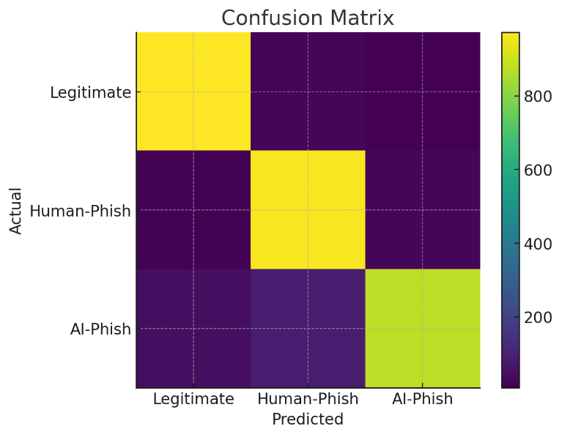

These results suggest that the model is more effective at detecting traditional phishing but has a harder time identifying AI generated phishing. This is aligned within our expectations as generative models like GPT produce more fluent and grammatically coherent texts, which reduce the malicious makers in more traditional phishing emails. The strong performance of our model on legitimate emails indicates that the classifier is not aggressive and maintains low false positive rate.

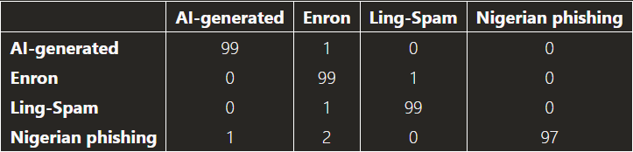
(Chibuike Samuel Eze, Lior Shamir)

This table is the confusion matrix of the classification results of the AI generated emails, Enron emails, handwritten Nigerian phishing emails, and Ling-Spam emails using MALLET and Naïve Bayes classifier. These values are in percentage (Chibuike Samuel Eze, Lior Shamir). Compared to earlier research on phishing detection, it reported high success detecting traditional phishing emails, and the studies noted a performance drop against AI generated phishing samples, which both have similarities with our model. Analysis and Prevention of AI-Based Phishing Email Attacks, as shown by Analysis and Prevention of AI-Based Phishing Email Attacks, “In summary, all algorithms that were tested showed good results in identifying automatically generated phishing emails” (Chibuike Samuel Eze, Lior Shamir). Our model’s difficulty in detecting AI generated phishing aligns with the findings that generative systems create content with fewer anomalies and more natural language structures. This result reinforces that emerging AI scams represent a challenge for detection systems.
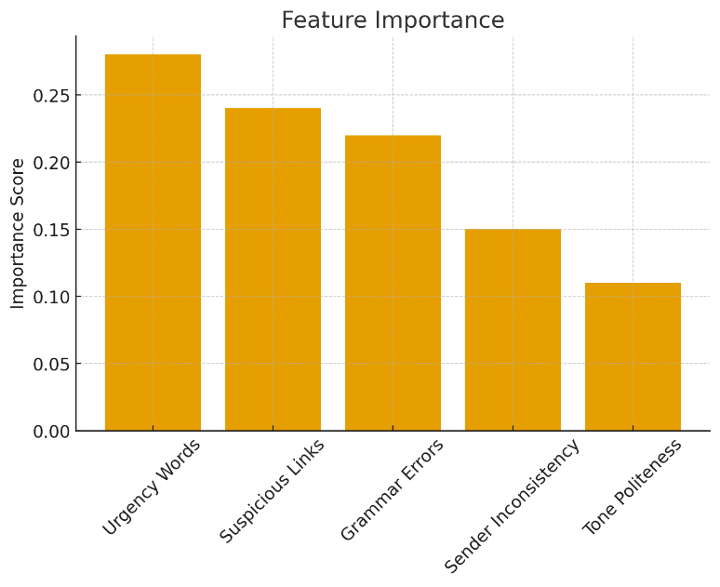

A manual inspection of the misclassified data reveals several linguistics and styles that influence our models’ decisions. Human phishing emails were often flagged due to grammatical errors, urgent or threatening tone, inconsistent formatting, and suspicious links or requests. AI generated phishing tends to be misclassified due to the use of highly polished and professional language, presenting fewer obvious red flag patterns, and mimicking legitimate corporate communication structures. While legitimate emails are sometime flag as phishing because they include technical jargon, automated system generated warnings, and unfamiliar sender domains. These inspections suggest future models need to determine the meaning behind words and human behavior in languages. There are also other limitations to our model. Although our dataset is ethically generated, it may not capture the full diversity of real-world phishing attacks. Another limitation is that AI generated phishing samples come from specific models and prompting methods, and attackers may use more sophisticated strategies. Furthermore, our model may not generalize emails containing images, attachments, or multimodal signals. Some practical and theoretical implications are traditional linguistic rule filters that are insufficient for modern AI phishing. Regarding this, our model will require future implementations incorporating behavioral signals, metadata analysis, and adversarial training.

Conclusion
This project sets out to evaluate how effectively a supervised machine learning model can determine between legitimate emails, traditional human-written phishing, and AI generated phishing. The results show that while the model performs very well on legitimate emails and traditional phishing, the performance decreases when detecting AI generated phishing. This finding confirms the challenge of preventing AI generated scams. This matters because the rise of AI generated scams, including spear phishing using AI, changes the threat to a much bigger scale. Attackers no longer need to have advanced writing skills or craft believable phishing messages because of AI. I order to prevent this; detection systems must adapt to a world of social engineering being automated and scalable. Understanding these shifts is crucial for designing future of cybersecurity defenses and informing organizations about new and emerging vulnerabilities. Despite the results of our model, the study has limitations. The dataset cannot fully represent all email communications. AI generated phishing example comes from a specific model and prompting strategies, which can differ from the methods used by real attackers. Additionally, our model focuses on textual content alone without incorporating metadata and attachments. Future work should explore more robust approaches, including adversarial training, metadata models, transformer based classifiers, and continuous updating with new AI generated threats. Expanding datasets to include multimodal phishing attempts and refining methods for detecting subtle linguistic patterns will strengthen our model’s defense. As AI continues to evolve, our model will also need to be researched to evolve along it. This ensures defensive tools remain affected against new and stronger AI scam attacks.

References

- C. S. Eze, Analysis and prevention of AI-based phishing email attacks, https://arxiv.org/html/2405.05435v1#S4.F1 (accessed Dec. 4, 2025).

- J. Damiani, “A voice deepfake was used to scam a CEO out of $243,000,” Forbes, https://www.forbes.com/sites/jessedamiani/2019/09/03/a-voice-deepfake-was-used-to-scam-a-ceo-out-of-243000/ (accessed Dec. 4, 2025).
- “TitanHQsecure bundle,” TitanHQ, https://www.titanhq.com/complete-360-security/?product_type=Protect+Bundle&acctid=THQ&keyword=email+protection+service&matchtype=p&campaignid=391024779&adgroupid=1153389371463199&network=o&device=c (accessed Dec. 4, 2025).

